Test Case: tc001_SPX_Dev5_Crear_Requisicion_Spot_Tipo_Cobro_CC
Step 1 - Enter username and password and click to button Enter : Credentials Entered
Image file-name: QC_Testing-tc001_SPX_Dev5_Crear_Requisicion_Spot_Tipo_Cobro_CC-1789482828927

Step 2 - Select to UEN and Access to Spot Buy Requisitions : UEN Correctly selected and Correct access
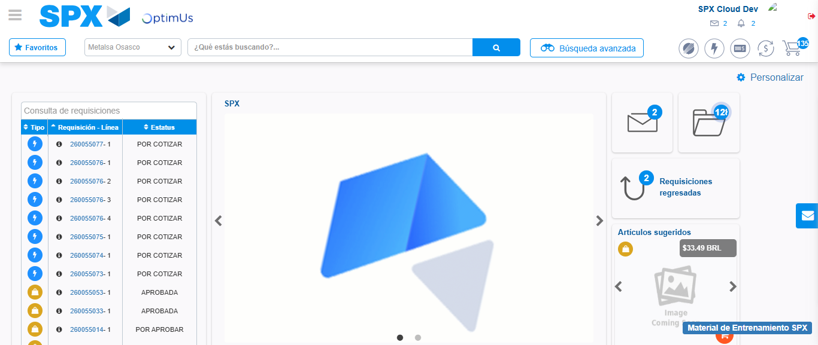Image file-name: QC_Testing-tc001_SPX_Dev5_Crear_Requisicion_Spot_Tipo_Cobro_CC-1789482851841

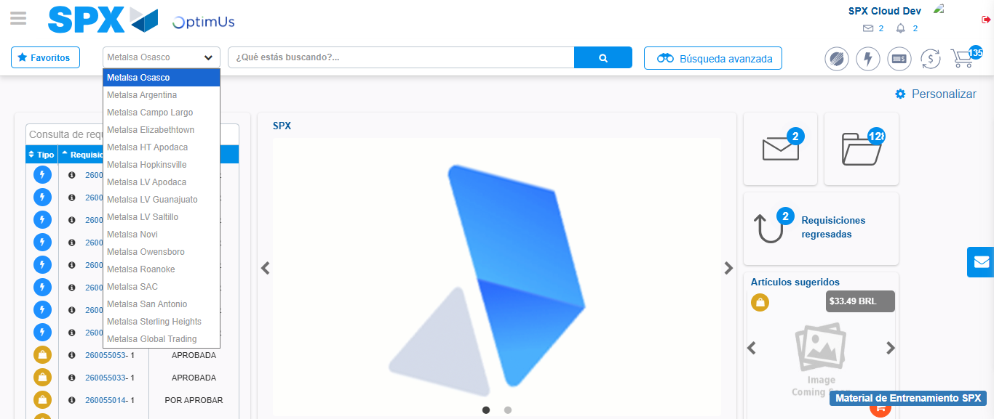Image file-name: QC_Testing-tc001_SPX_Dev5_Crear_Requisicion_Spot_Tipo_Cobro_CC-1789482852443

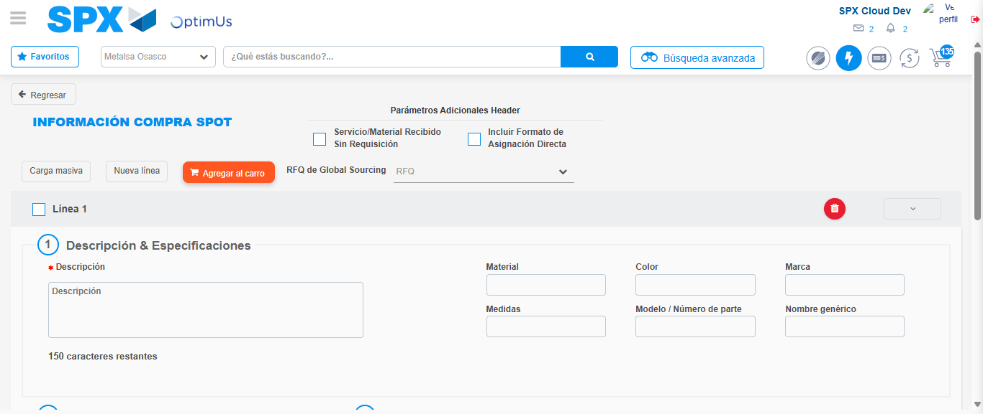Image file-name: QC_Testing-tc001_SPX_Dev5_Crear_Requisicion_Spot_Tipo_Cobro_CC-1789482857073

Step 3 - Data Capture Spot Buy Requisition : Data captured correctly
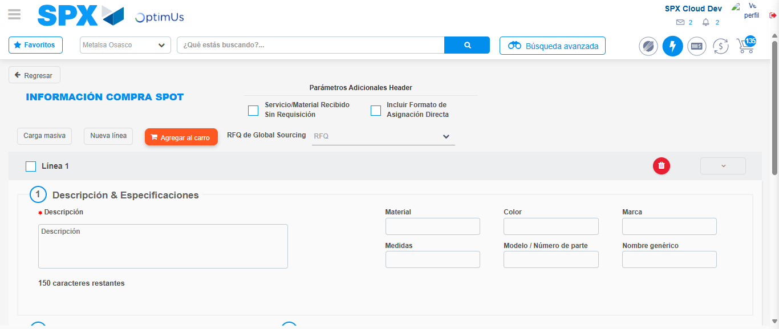Image file-name: QC_Testing-tc001_SPX_Dev5_Crear_Requisicion_Spot_Tipo_Cobro_CC-1789482857403

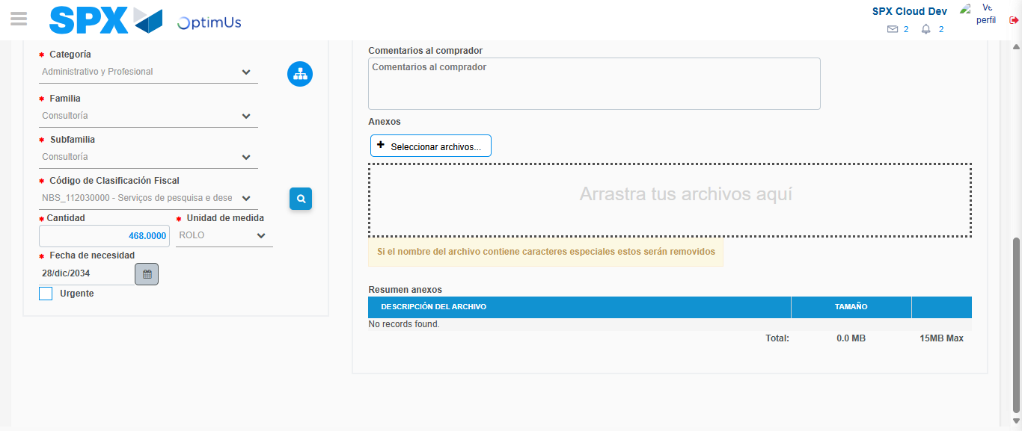Image file-name: QC_Testing-tc001_SPX_Dev5_Crear_Requisicion_Spot_Tipo_Cobro_CC-1789482873254

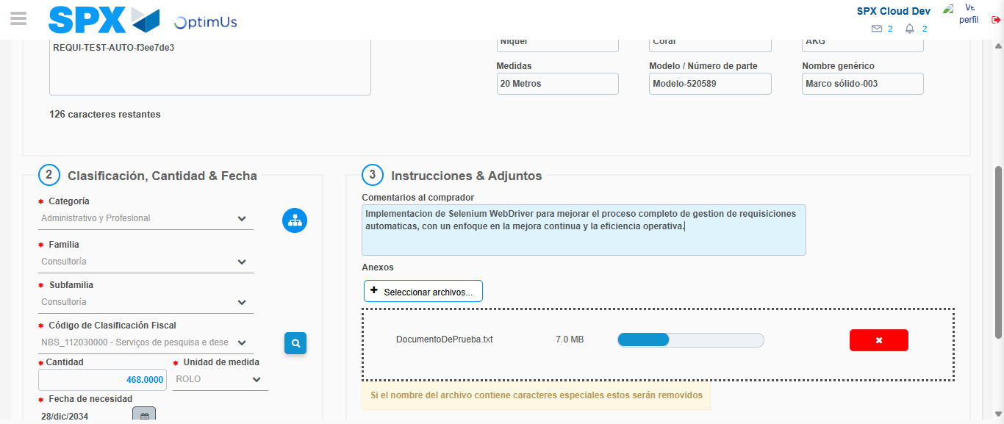Image file-name: QC_Testing-tc001_SPX_Dev5_Crear_Requisicion_Spot_Tipo_Cobro_CC-1789482874167

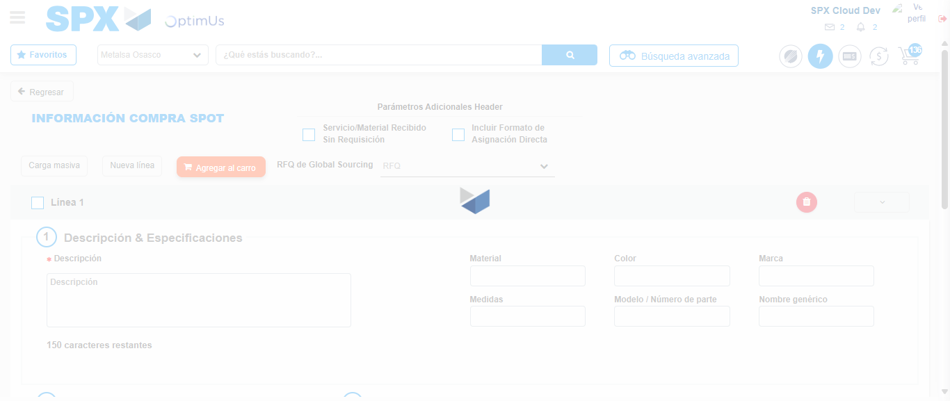Image file-name: QC_Testing-tc001_SPX_Dev5_Crear_Requisicion_Spot_Tipo_Cobro_CC-1789482875632

Step 7 - Return to Main Page SPX : Return to Main Page SPX
Image file-name: QC_Testing-tc001_SPX_Dev5_Crear_Requisicion_Spot_Tipo_Cobro_CC-1789482851841

Image file-name: QC_Testing-tc001_SPX_Dev5_Crear_Requisicion_Spot_Tipo_Cobro_CC-1789482852443

Image file-name: QC_Testing-tc001_SPX_Dev5_Crear_Requisicion_Spot_Tipo_Cobro_CC-1789482857073

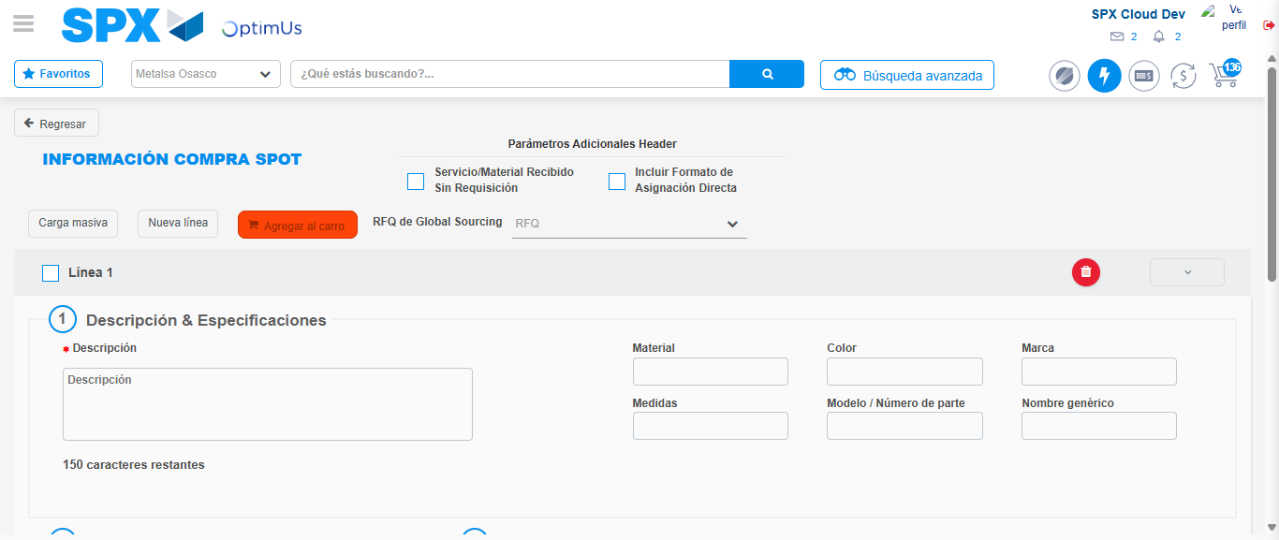Image file-name: QC_Testing-tc001_SPX_Dev5_Crear_Requisicion_Spot_Tipo_Cobro_CC-1789482877956

Image file-name: QC_Testing-tc001_SPX_Dev5_Crear_Requisicion_Spot_Tipo_Cobro_CC-1789482878165

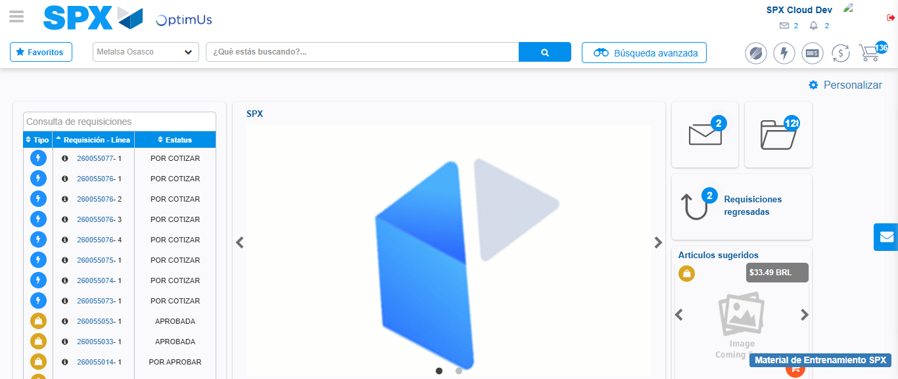Image file-name: QC_Testing-tc001_SPX_Dev5_Crear_Requisicion_Spot_Tipo_Cobro_CC-1789482899237

Step 8 - Log Out : Log Out SPX
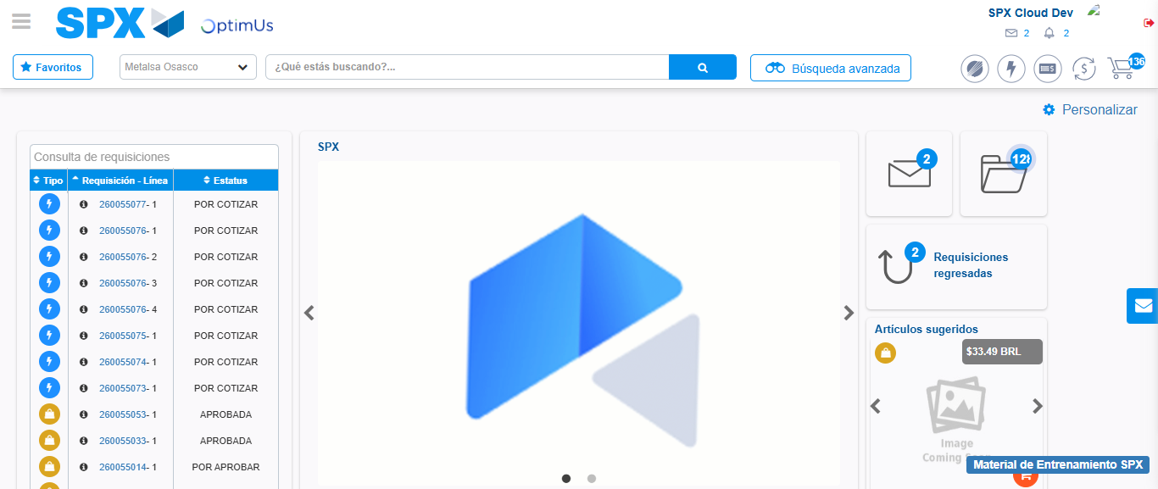Image file-name: QC_Testing-tc001_SPX_Dev5_Crear_Requisicion_Spot_Tipo_Cobro_CC-1789482899571

